HW2

數位影像處理概論

資工三甲

楊孟繁學

4A8G0039

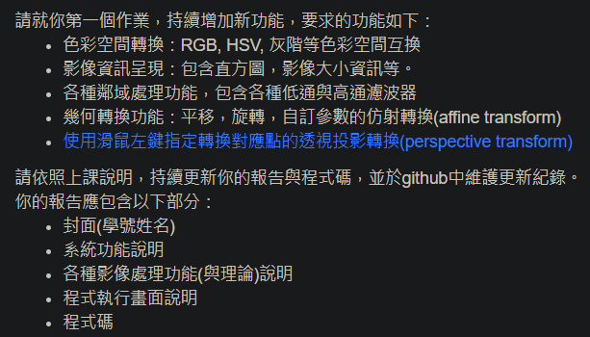

完整程式: <https://github.com/4A8G0039/HW_OpenCV/tree/master/Master>

主程式 : [controller.py](https://github.com/4A8G0039/HW_OpenCV/blob/master/Master/controller.py)

我使用整合Qt5到python的PySide2製作介面，程式碼太多所以我就直接丟github的連結。

主頁面 : [ui_main_window.py](https://github.com/4A8G0039/HW_OpenCV/blob/master/Master/ui_main_window.py)

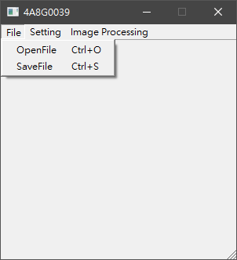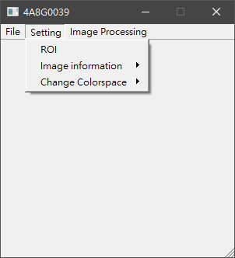

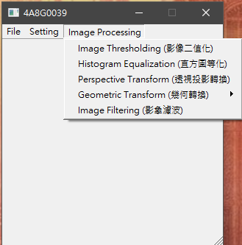

OpenFile:

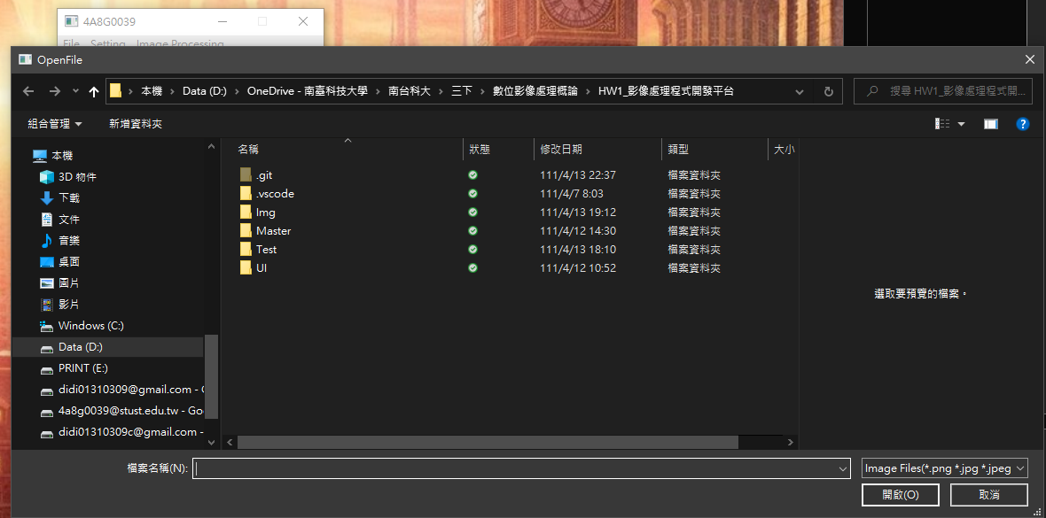

SaveFile:

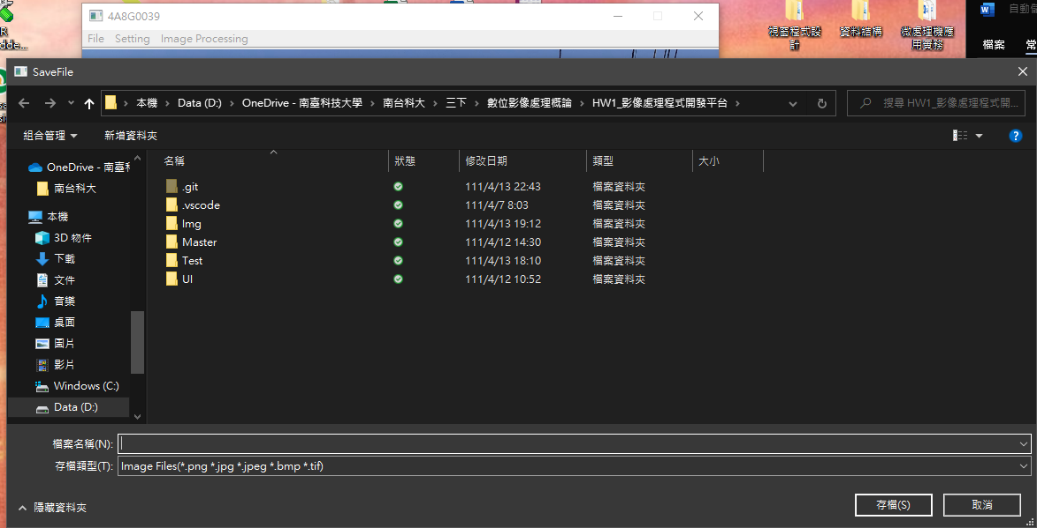

ROI: [ui_roi_window.py](https://github.com/4A8G0039/HW_OpenCV/blob/master/Master/ui_roi_window.py)

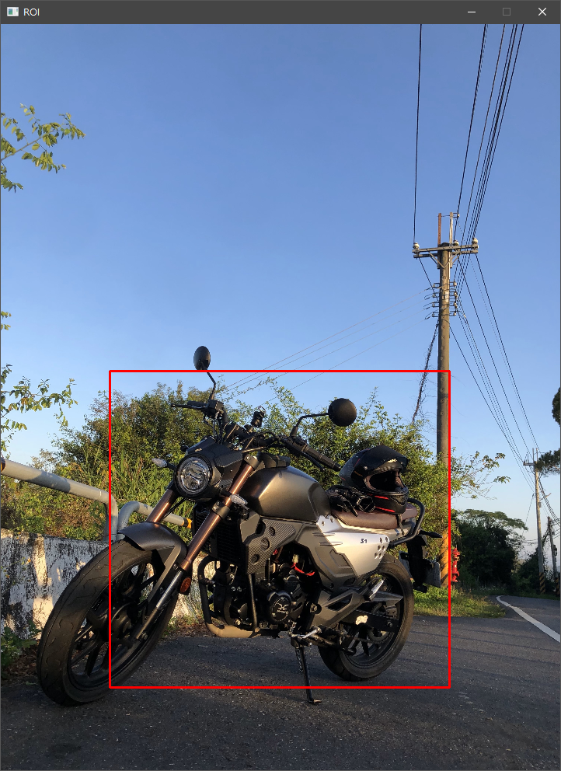

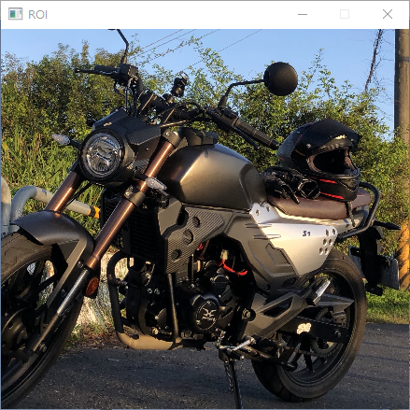

Show histogram: [ui_show_histogram_window.py](https://github.com/4A8G0039/HW_OpenCV/blob/master/Master/ui_show_histogram_window.py)

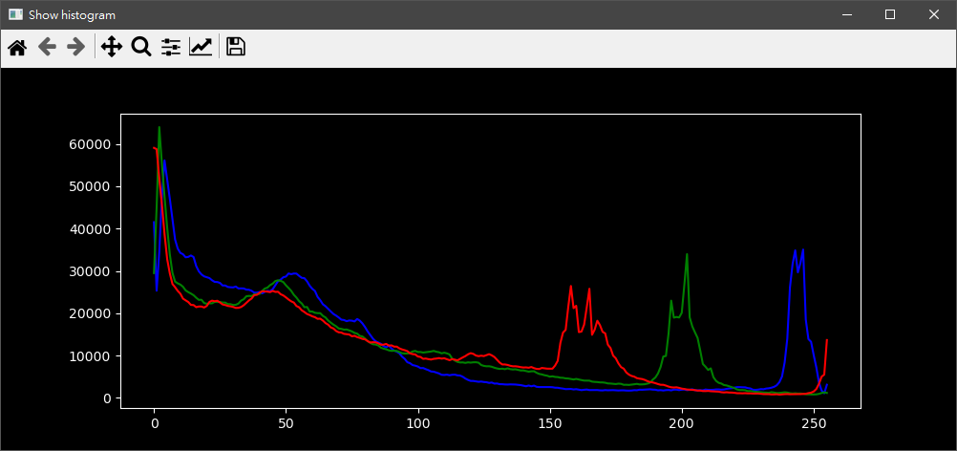

Show Imgsize:

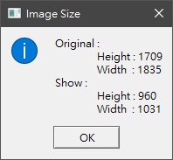

HSV: [ui_change_hsv_window.py](https://github.com/4A8G0039/HW_OpenCV/blob/master/Master/ui_change_hsv_window.py)

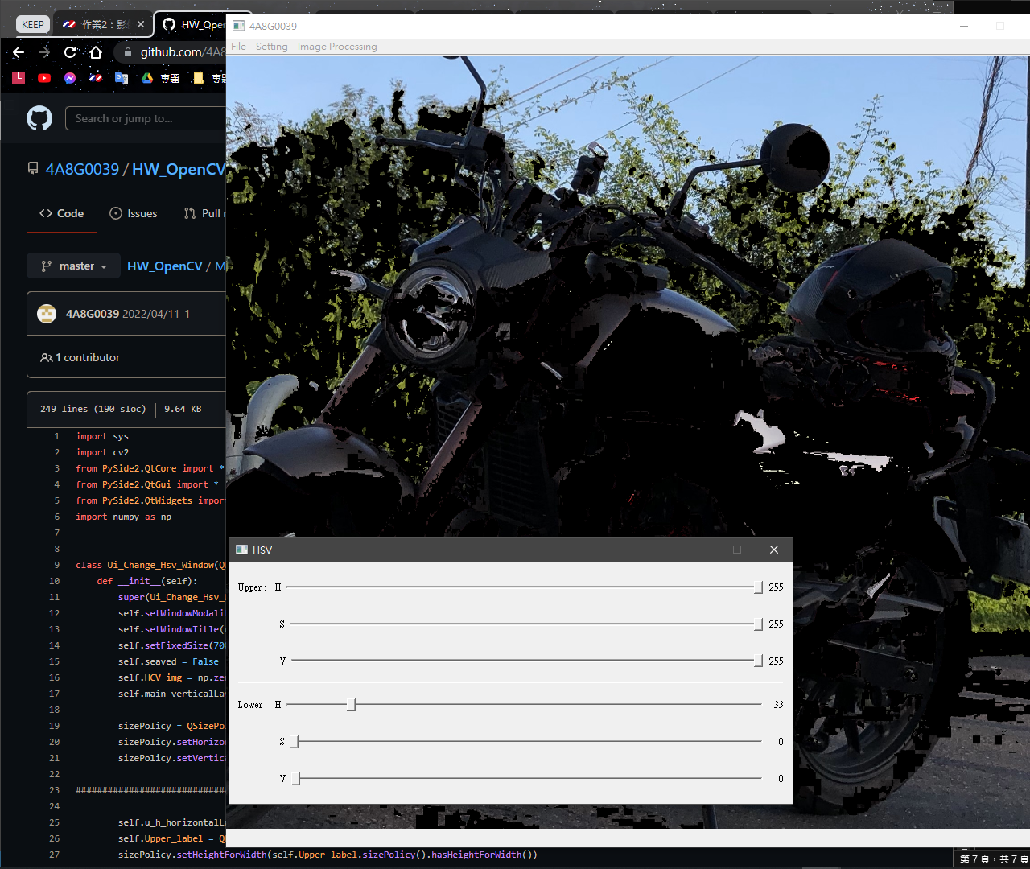

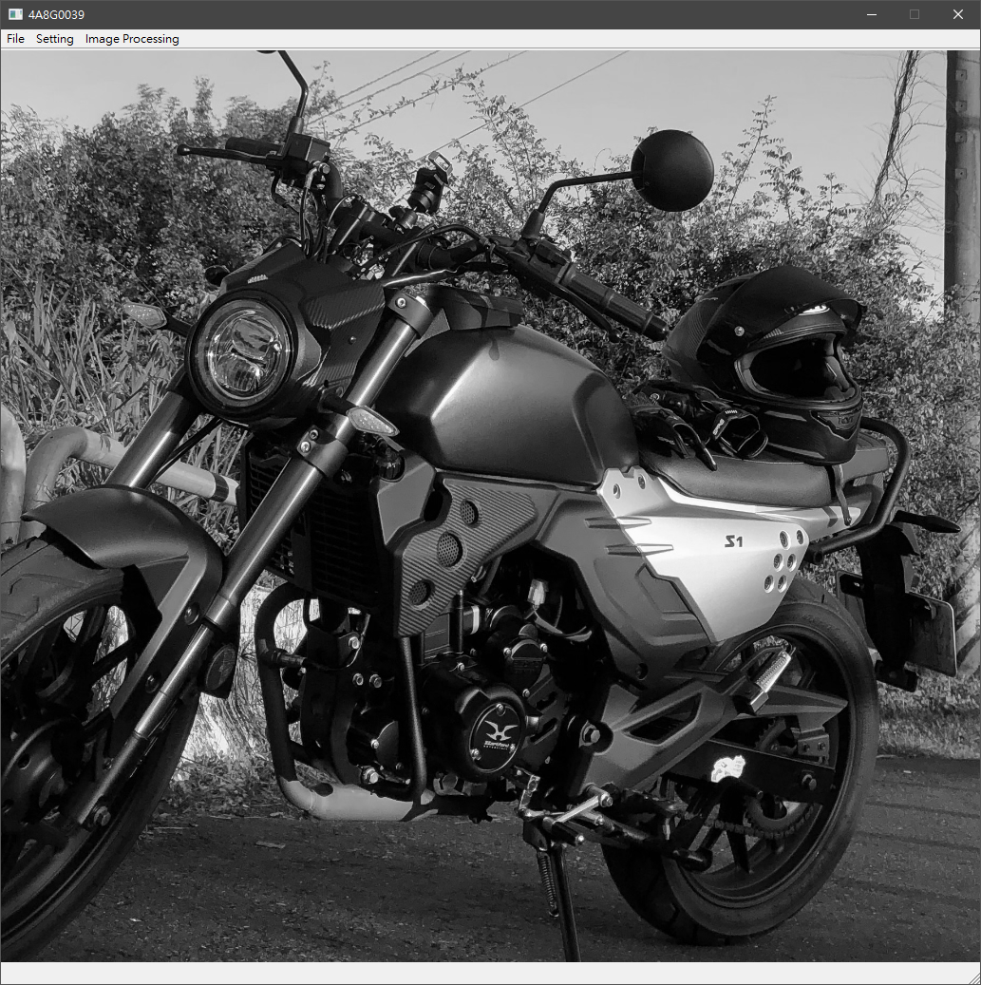GRAY:

Image Thresholding (影像二值化):

[ui_image_thresholding_window.py](https://github.com/4A8G0039/HW_OpenCV/blob/master/Master/ui_image_thresholding_window.py)

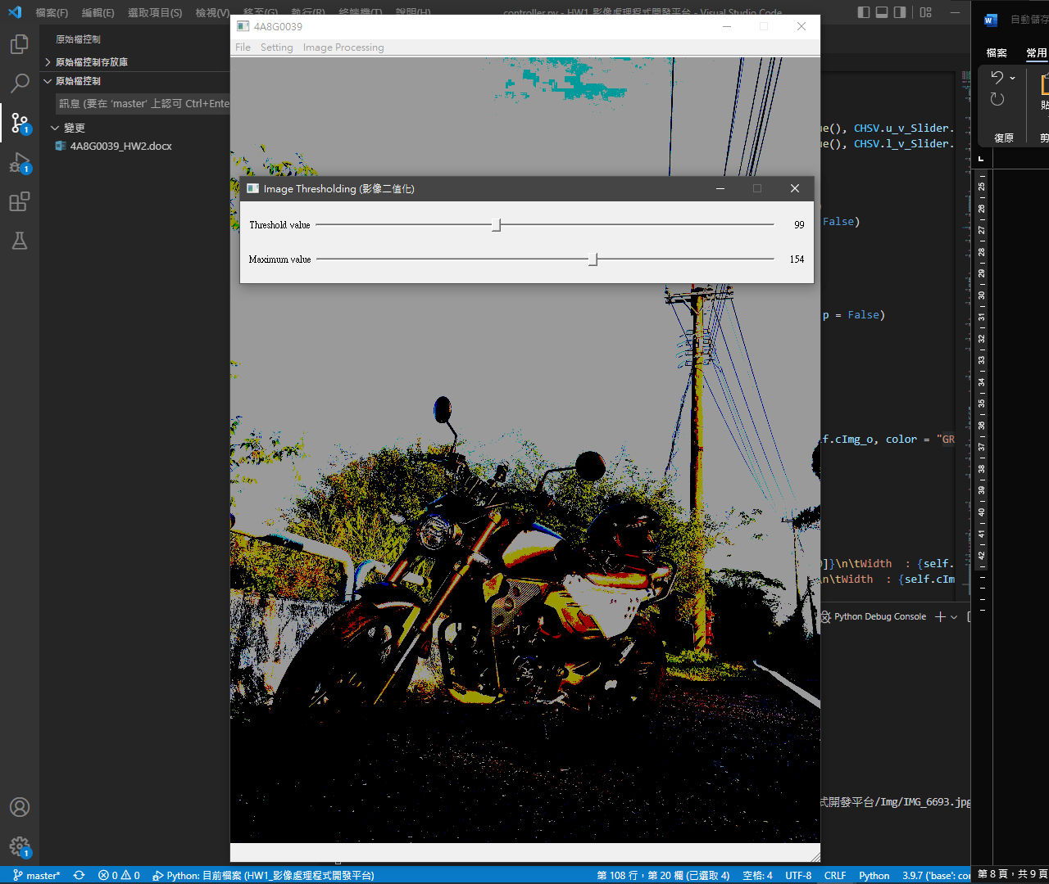

Histogram Equalization (直方圖等化):

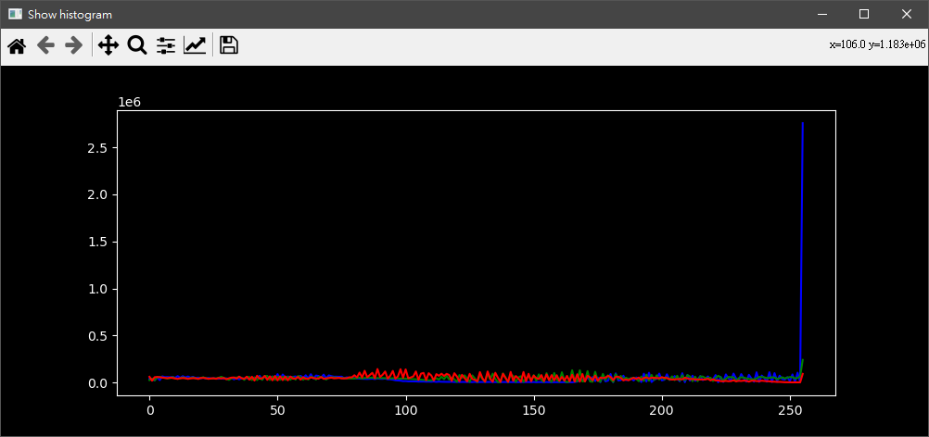

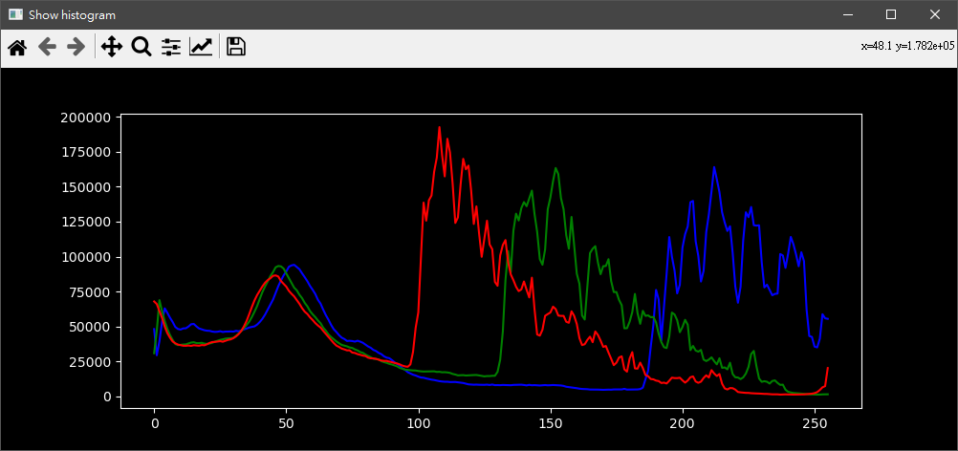

Perspective Transform (透視投影轉換):

[ui_perspective_transform_window.py](https://github.com/4A8G0039/HW_OpenCV/blob/master/Master/ui_perspective_transform_window.py)

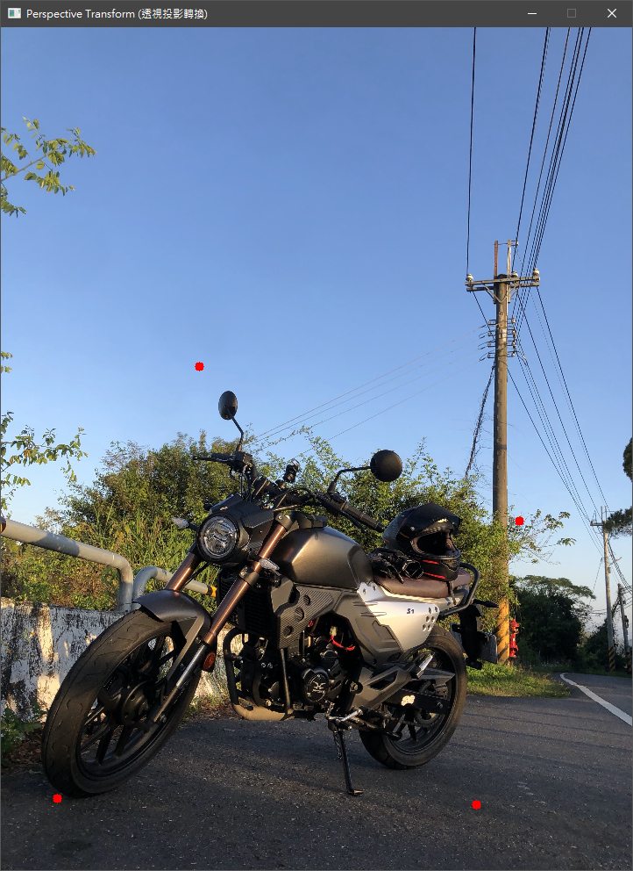

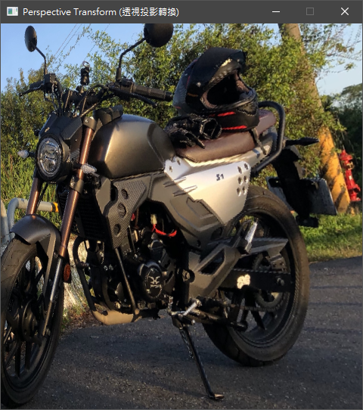

Translate Rotate (平移/旋轉):

[ui_translate_rotate_window.py](https://github.com/4A8G0039/HW_OpenCV/blob/master/Master/ui_translate_rotate_window.py)

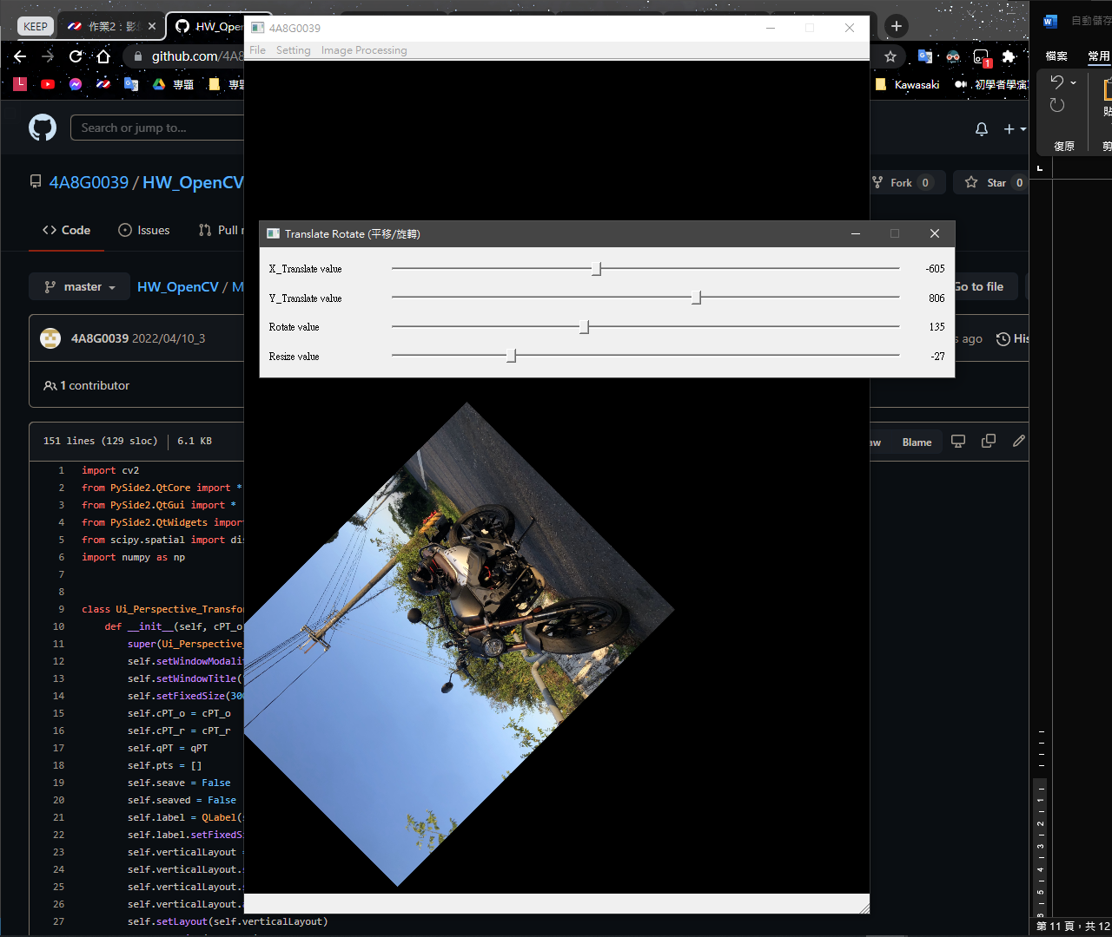

Affine Transform (仿射轉換):

[ui_affine_transform_window.py](https://github.com/4A8G0039/HW_OpenCV/blob/master/Master/ui_affine_transform_window.py)

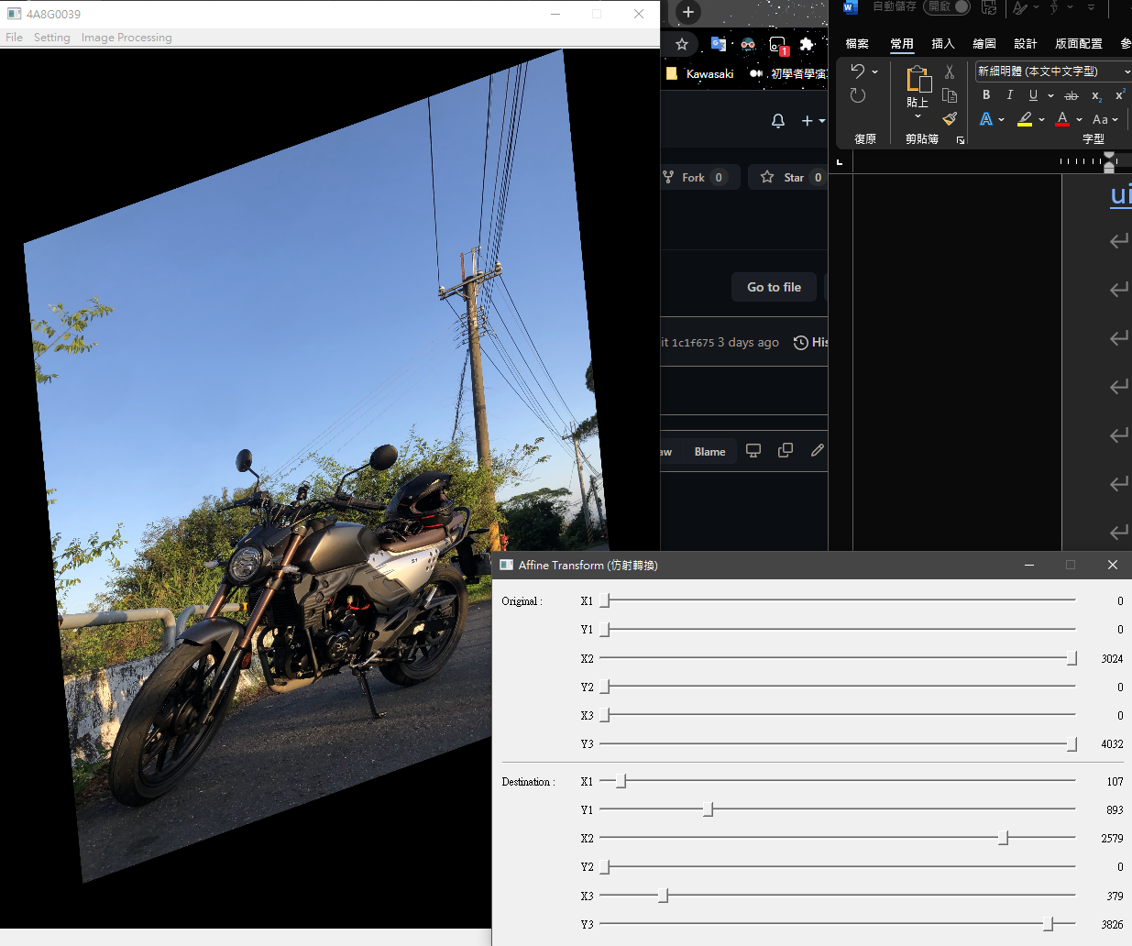

Image Filtering (影象濾波):

[ui_image_filtering_window.py](https://github.com/4A8G0039/HW_OpenCV/blob/master/Master/ui_image_filtering_window.py)

[image_filtering.py](https://github.com/4A8G0039/HW_OpenCV/blob/master/Master/image_filtering.py)

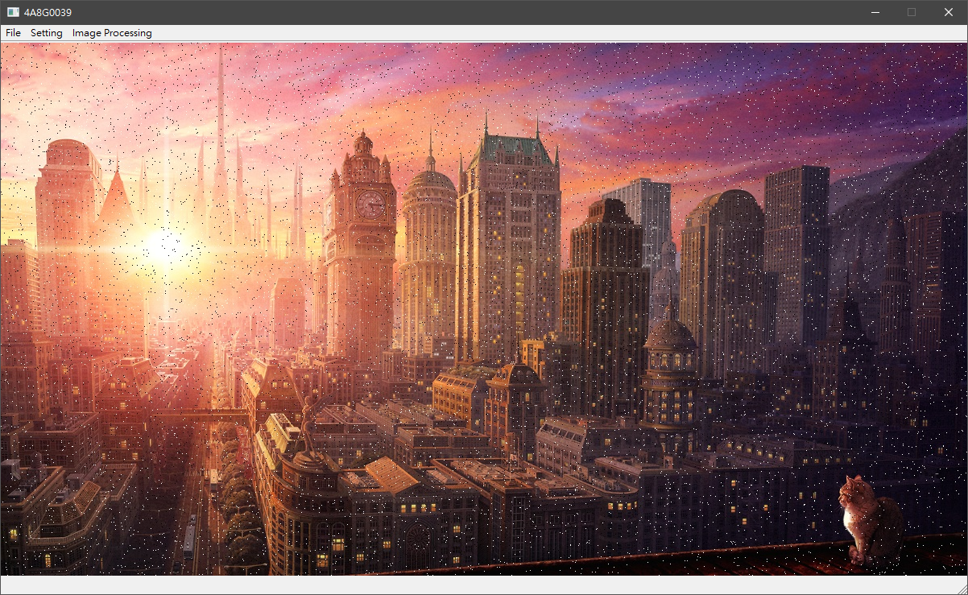

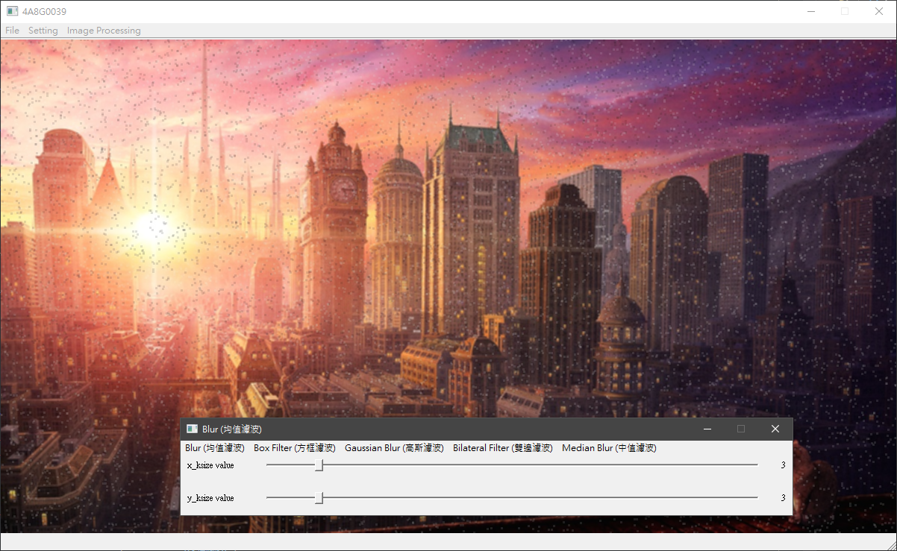Blur (均值濾波):

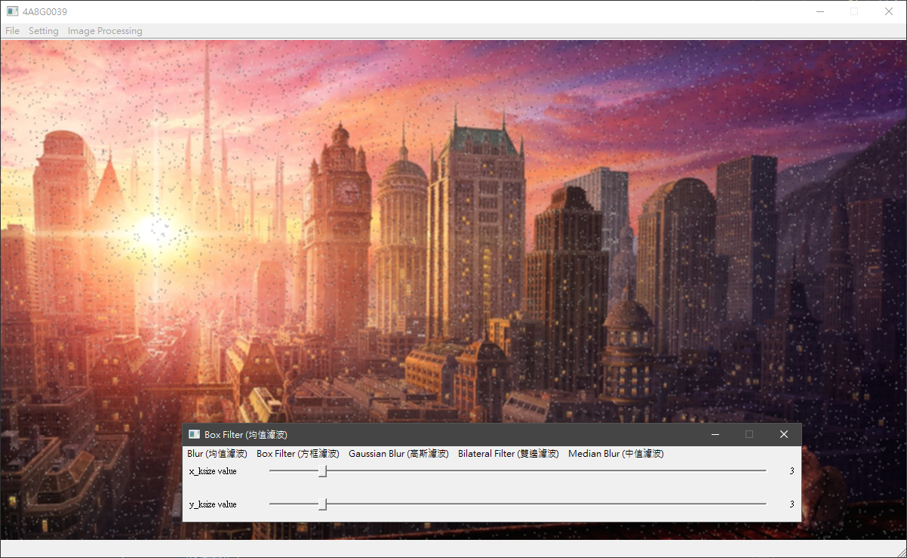Box Filter (方框濾波):

Gaussian Blur (高斯濾波):

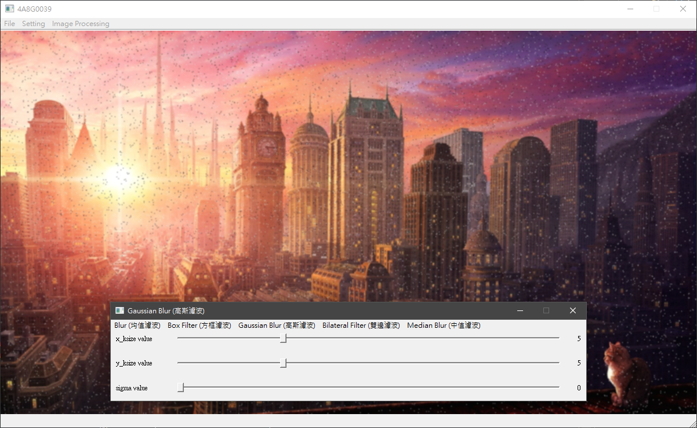

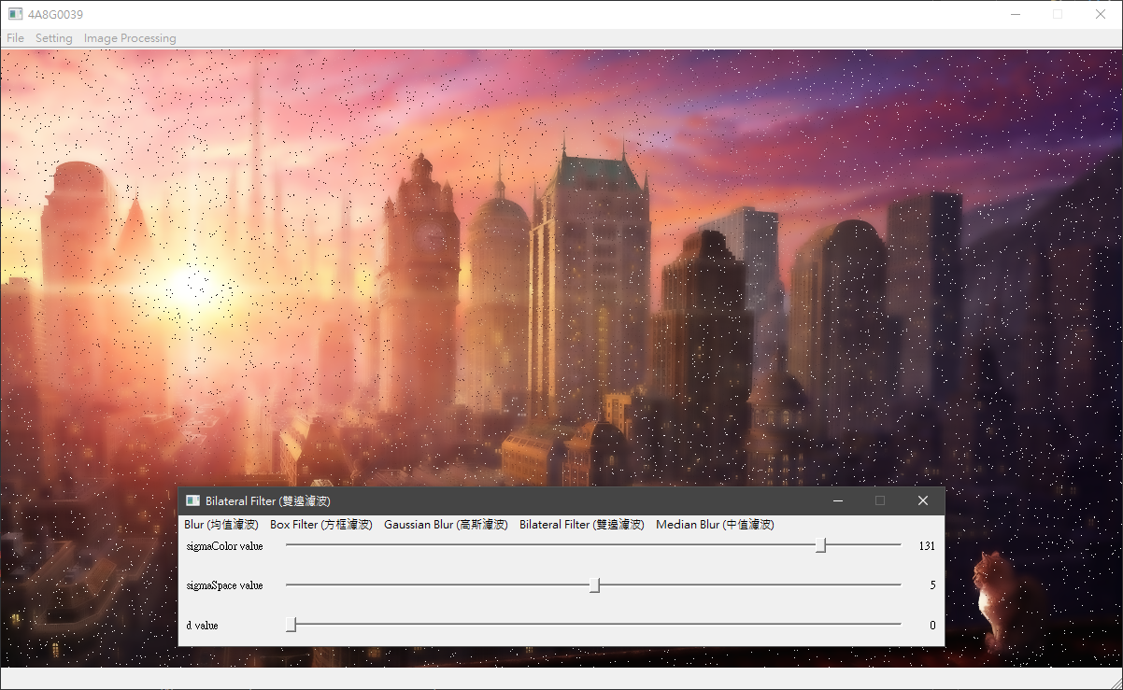Bilateral Filter (雙邊濾波):

Median Blur (中值濾波):

